Project Information: (Rev: 5.21)

Project Name:
Project St. Address:
Project City & Zip Code:

SECTION 08 36 13.2 (3-Part Specifications) Insulated Frame & Air Infiltration (Rated)

GLAZED SECTIONAL OVERHEAD DOORS

(Insulated Frames, Air Infiltration & NFRC Rated, US Energy Code Compliant in All U.S. States)

PART 1 - GENERAL

  - SUMMARY - Section Includes:

- Provide Full View Glazed Aluminum Sectional Type; Glass Garage Doors(s) with Insulated Frames, Insulated Glass Units (Offered in: Obscured, Transparent Clear, Tinted), or Insulated Aluminum Solid Panels, as designed per elevation. Frame rails will consist of Extruded Aluminum alloy with either: Clear Anodizing, Powder Coating, Kynar Paint, or as specified by Architect, or Project Rep., for color and type. System will also include all brackets, track system guides, counterbalance, stainless steel hinges, stainless steel rollers, stainless steel fixture hardware, electric motor or manual chain hoist, for a complete finish and operational installation.

  - See 2.02 for Performance Requirements, 2.03 for Components; such as Glazing (type / color), track type, operator type, etc., and 2.04 for finish (type / color).

  - Provide system to suit field conditions and openings with applicable headroom and side room.

  - RELATED REQUIREMENTS (Note: Architect of record to supply additional sections as required.)

- Section 06 10 00: Rough Carpentry and Framing. [Adhere to shop drawing min. requirements] General Contractor to provide all structural support, blocking, and/or anchoring points.

- Section 26 05 00: Basic Materials: Empty conduit from control units to door operator. [By GC]

- Section 26 05 00: Electrical service to disconnect near door operator [120v dedicated receptacle]

  - SUBMITTALS – [Administrative Requirements, for submittal procedures]

- Shop Drawings: Indicate accessories, opening dimensions and required tolerances, connection details, anchorage, spacing, hardware locations, and installation details.

- Product Certification Report: Product line information specific to the performance requirements in section 2.02, and a current copy of the NFRC Product License Agreement; for verification of compliance.

- NFRC Product Certification Authorization Reports (NFRC - C.A.R.): Provide a summary of the conforming test procedures and result, which include, but are not limited to: Air Infiltration, Water Resistance, Wind Load, and Structural Testing; in accordance with ASTM E-283, ASTM E-330, ASTM E-331, ASTM E-547.

- Samples: Submit two frame finish samples, and two panel samples; illustrating color and finish.

- Manufacturer's Installation Instructions: Include any known special procedures required by project conditions; for review by the Architect and Engineer of record.

- Operator Manuals [Data Sheet required; if electric operators are specified]: Include specific model #, data for motor and transmission, gearing, lubrication frequency, maintenance, spare part sources, troubleshooting, and adjusting.

- Operator Station Control [Data Sheet required; if electric operators are specified]: Include specific model #, type, and information data sheet for motor control. [Required if the electric operators are specified]

- Aux. Safety Components (Optional) [Data Sheet required; if the electric operators are specified]: Include specific model #, data sheet, maintenance, spare part sources, and manual.

- Warranty: Submit manufacturer warranty letter; after installation occurs. Ensure that the warranty forms have been completed in Owner's name, with jobsite address, pictures for verification that the installation occurred correctly, and is registered with manufacturer.

- Sustainable Design Submittals: (LEED, National Green Building Standards, Green Globes)

- Submit documentation from manufacturer of the amounts of pre-consumer and post-consumer recycled content for products specified.

- Submit documentation showing manufacturing locations and origins of materials for products manufactured and sourced within 500 miles of project location.

  - QUALITY ASSURANCE

- Manufacturer Qualifications: Company specializing in manufacturing of “Full View Type - Glass Garage Doors” specified in this section, with a minimum (65) years or more of documented experience. The Fenestration products must be tested “as a whole system” vs. relying on the data of (1) type of glazing panel alone. The test results must be certified by an independent third-party laboratory, adhere to a quality assurance program; which is re-certified every (2) years, and provide Current NFRC Licensing; with permanent identification plaque, and current CPD #’s (Certified Products Database #’s) for verification of specific glass types. See Glazing Panel Type (for specific CPD #) in section 2.03.G

- The Fenestration products shall be tested as a whole system, with test results verified by a third-party laboratory.

- Independent third-party laboratory shall have current NFRC licensing.

- Installer Qualifications: If product installation occurs within the State of California (where the Factory is located), a Factory Direct installation is recommended, but not required. Alternatively, a Company specializing in performing the work within this section, which has a min. 5 years of experience, and a letter of authorization by the Manufacturer.

- Applicable Codes: Follow all Federal, State, County, and City Building codes as applicable; which include: NEC (National Electric Code) for wiring of motor and motor control requirements as appl., State Energy Code (Specific to Air Infiltration and sealing the Building Envelope); whereas the product specified in this section is “tested as a whole unit” to provide NFRC Certified results regarding: U-Factors, SHGC, VT, and Air Infiltration rating to meet the energy calculations; required per code.

- Products Requiring Electrical Connection: Listed and classified by UL (Underwriters Laboratories Inc.), as suitable for the purpose specified.

- Components: All components found in section 2.03 are to be provided by the door manufacturer

- Single-Source Responsibility Supplier: Provide Door(s), tracks, motors, and accessories from one manufacturer; to ensure that manufacturers’ recommendation on various parts have been tested, and properly combined to function as described.

  - DELIVERY, STORAGE, AND HANDLING

- Deliver materials to site in manufacturer’s original, unopened containers and packaging, with labels clearly identifying product name, manufacturer, and model: Ex. “Insulated Frame Line”.

- Storage and Handling: Store materials in clean, dry, interior area in accordance with manufacturer’s instructions. Protect materials from damage during handling and installation.

  - WARRANTY

- Provide Closeout Submittals for warranty requirements: Submit manufacturer warranty letter; after installation occurs. Ensure that the warranty forms have been completed in Owner's name, with jobsite address, pictures for verification that the installation occurred correctly, and is registered with manufacturer.

- Manufacturer shall provide high cycle life hardware; as specified on general requirements. Hardware Includes: track hardware, heavy-duty stainless steel hinges, stainless steel sealed roller, high cycle galvanized springs (as avail. by manufacturer), and high tensile aluminum alloy frame rails.

PART 2 - PRODUCTS

2.01 SYSTEM MANUFACTURER

- A manufacturer with no less than 65 years of experience in fabricating “Fully Insulated Frame Technology” with ASTM Air & Water Certifications; per NFRC requirements, for “Full View Sectional Glass Garage Doors”: Basis of Design
bp - Glass Garage Doors & Entry Systems, Inc. - Factory Direct & World Wide Shipping.

Product Model(s):

bp - 350 (4 ft.-8ft. wide x 8 ft. high) Standard Duty
bp - 450 HD (8 ft.-16 ft. wide x 12 ft. high) Heavy Duty
bp - 550 SHD (16 ft.-24 ft. wide x 16 ft. high) Super Heavy Duty

Product Line(s): [The product lines below, are optional, and can be combined (Hybrid Style) and are adaptable to any size & model above.]

Insulated: Typ. use: Sealing the Building Envelope (Code Compliant, Sealed, HVAC Spaces)
Hurricane: Typ. use: High Wind & Impact; Miami / Dade NOA (Hurricane Zones)
California: Typ. use: Garages & Warehouse Spaces (Non-Conditioned Spaces)

- To be verified by bp: for width, height, weight, and Factory Safety Standards: [Call Factory for Assistance to designate exact Model # and Line#.]

- Phone: Toll Free: (877) 442-1716, Direct: (626) 442-1716

- Address: 1511 W. 2nd St., Pomona, CA 91766

- Email Request for Info: Service@GlassGarageDoors.com

4. Download Info. / Website: www.GlassGarageDoors.com

2.02 PERFORMANCE AND CERTIFICATION REQUIREMENTS:

- Product Certification Reports: Product line information specific to performance requirements, must adhere to NFRC and IECC (Energy Code) Requirements for Exterior Doors & Windows. All products must comply with all the applicable requirements of this subsection; which include independent laboratory testing, certified results, and a current copy of the NFRC Licensing Agreement; for verification of Compliance.
- NFRC Certification Authorization Reports (NFRC – C.A.R.): Provide a summary the conforming test procedures and results, which include, but are not limited to: Air Infiltration, Water Resistance, Wind Load, and Structural Testing; in accordance with ASTM E-283, ASTM E-330, ASTM E-331, ASTM E-547
- Entire assembly (including frame rails, glass, and panels) shall be certified by the NFRC (National Fenestration Rating Council): Products shall bear “NFRC Certified labeling”; which indicates energy performance and technical information. Certifications and Licensing agreements with the NFRC; must be current at the time of manufacturing and/or installation, and shall meet or exceed 2012 – IECC (International Energy Conservation Code – 2016 to current).

- Authorized Certifications: No other pseudo certifications will be acceptable, other than the governing body, known as the NFRC. Unacceptable pseudo certifications include, but are not limited to: Letters by manufacturers, uncertified laboratories, website pages, or other forms of advertising, etc. Only NFRC licensed products will be accepted.

- Fenestration U-Factors & Thermal Transmittance: Per NFRC 100 (Incl. Glazing: U-Factors) which supersedes ANSI/DASMA105

- Fenestration SHGC & VT: (Solar Heat Gain Coefficient & Visible Transmittance) Per NFRC 200

- Air Leakage Performance Certification: Per NFRC 400 (See 2.02-C below)

- Product must be provided with temporary labels on all glazing and/or panels (for inspection purposes; with certified results) demonstrating compliance to the building inspector, and / or enforcement agency.

- Product must be provided with a permanent plaque riveted at the bottom interior (NFRC Certified labeling) for inspection by the Architect and/or Representative of record; also demonstrating compliance to the building inspector, and / or enforcement agency.

- Fenestration product performance must be certified in accordance with NFRC and requires supporting documentations: Product must be provided with a “Certificate of Acceptance” (Found at the end of this section) to be provided for the Architect of Record; during the submittal process. In addition, provide a copy for the Inspection Bureau of record, or the Dept. of Building & Safety; as applicable. This Fenestration Certificate will be used as a verifiable source; which traces back to the www.NFRC.org website; for validating the manufacturer’s compliance.

- Air Leakage Performance Certification: Required (per Building Code) by default; when measured in accordance with ASTM E-283 and ANSI / DASMA 105: Air Infiltration Test Pressure Differential: 6.24 pounds per square inch. Entire assembly: glass, panels, and Frames shall be certified by an independent Testing Lab; which indicates energy performance, wind load, cyclical testing, and technical information, when measured in accordance with NFRC 100, and NFRC 400 (As Licensed on the NFRC.org website, and traces back to the manufacturer; for validating compliance.)

  - Fully Insulated Frame Stiles & Rails: All hollow voids within the frame system, must be filled with a cooperative band to seal all sections, to maintain an airtight seal; for meeting the Building Energy Code Requirements.

- Water Resistant Infiltration Package: System must be tested and certified to mitigate water infiltration, when measured in accordance with ASTM E 331 and ASTM E 547 water testing methods. This package also includes: [(1) each per door] a ½” high x 4"-6” deep x door width; Solid Aluminum Threshold. Designed for heavy traffic [Pedestrian or Vehicular] with ADA compliance. The Water Resistance Package must be combined with the bp – Fully Insulated Frame System; certification per NFRC 400. (Verify currently Licensed per the NFRC.org Website, prior to ordering.) A notarized manufacturers’ letter must be provided to the installer, and Architect of record, which certifies the installation was completed per the Factory Specification, and testing methods above. A bp Factory Rep. must be present during the installation, to verify the proper sealant and installation methods are applied. A certification letter will be provided after installation is complete.

- Wind Load: Withstand positive and negative wind loads equal to 25 PSF / 99mph, or as specified by local code; without damage or permanent set, when tested in accordance with ASTM E 330, using 10 second duration of maximum load. (As Licensed on the NFRC.org Website, with Certified Results).

- Test Reports: Provide an “NFRC - Certified Report” summary of the conforming test procedures and results, which include, but are not limited to: Air Infiltration, Water Resistance, Load, and Structural Testing in accordance with ASTM E-283, ASTM E-330, ASTM E-331, ASTM E-547. (As Licensed on the NFRC.org Website, per Certified Results).

- Torsion Springs: Provide High Cycle Spring Life (20,000–100,000 cycles), as available per Manufacturer engineered calculations; at time of manufacture.

- Hinges & Fixtures: 12ga, Stainless Steel, Laser Cut, and Precision Formed, offset numbered type, and graduated to ensure weather tight fit.

- Rollers: Stainless Steel Stem, Bushing, and Fitting, with polymer coated races, 500lb-800lb capacity each roller, with precision Stainless Steel Ball Bearings, and mechanically sealed on both sides. [Note: Roller size (2” or 3”) must match the appropriate track size]

- Additional Components: All components found in section 2.03 are to be provided by the door manufacturer (as a single source supplier) to ensure that manufacturers recommendations on various parts, have been tested, and properly combined to function as described.

- Stiles and Rails: Extruded aluminum with tensile strength of at least 38 ksi; (approximately double the strength of 6063-T6 alloy) and complying with ANSI/DASMA 102 / 103.

2.03 COMPONENTS

- Models: bp-350 (Top / Btm. rails: 3-1/4” tall), bp-450HD (Top / Btm. rails: 5-3/8” tall), & bp-550SHD (Top / Btm. rails: 7-3/8” tall); or as required per the Manufacturer’s safety recommendations for the width, height, weight, and track operating clearance.

- Horizontal Meeting Rails: Combined overall width; 2-3/4” inch.

- Vertical Intermediate Center Mullions: 1-1/2” inch wide.

- End Stiles: 3-1/4” inch wide.

- Structural Fastening: Zinc-plated 5/16 inch thru-bolts, nuts, and tension indicating washers to secure stiles and rails.

- Door Thickness: 1 3/4” inch, nominal.

- Joints: Smooth and tight fitting mitered joints.

- Glass Stop Moldings: “Aluminum” snap-in bead type. (No other material types accepted!)

- Configuration & Elevation: Product should conform to the general drawings provided, and consistent to the number of panels drawn in width, number of panels drawn in height; or per the safety limits and recommendations of the manufacturer.

- Glazing Panel Type: Note: (Chosen by Architect of Record, or Project Rep.) [Call Factory for Assistance to designate exact Model #: (877) 442-1716]

- Insulated Glass Panels: CBA Certified Products through IGCC; tested in accordance with ASTM E-1290. Tempered glass, FT (Full Tempered); ASTM C-1036 and ASTM C-1048, Condition A, Quality q3, and meeting safety criteria of CPSC 16 CFR 1201, Categories 1-2, and ANSI Z97.1

- Makeup / Color / Type: [½” O.A. Thickness]: 1/8” Clear Tempered, Low-E Solarban-60 IG Units; (as per NFRC CPD# BPC-A-1-00049-00001) with 1/4” air spacer, and 1/8” clear Tempered; (required by code) – [as default].

  - Additional Glass or Panel Choices: Colors, Types, Transparent, Obscured, or other, have been tested and provided for on the CPD (Certified Products Database) of the searchable NFRC Website: http://search.nfrc.org/search/cpd/cpd_search_detail.aspx?cpdnum=BPC-A-1

- Counter Balance: Galvanized torsion springs, head plates, and center spring supports mounted on continuous torsion bar and adjusted to counter weight and travel of door.

- Cable Drums: Die cast aluminum, paired for track type indicated.

- Lift Cables: High tension aircraft cable: 1/8”-1/4” diameter; per Manufacturer requirements

- Springs: Galvanized and related hardware as necessary for system indicated.

- Track: Call Factory for Assistance: (877) 442-1716 to designate Track Type] designated by the provided drawings and field conditions, or chose the appropriate option below. As provided with all track systems: a continuous (floor to ceiling) steel support angles, with a slight taper; to ensure weather-tight fit when in the closed position.

- Track System Type: Standard Lift - [as default]; Requires 24” min. headroom clearance from door opening height, to the underside of a ceiling, or fist obstruction: Ex.: Bottom side of a joist, HVAC, Mechanical, Electrical, Plumbing, or other materials that could interfere with the door operation. See shop drawings for more clarity on unobstructed clearances], or in accordance with manufacturer’s recommendations based on door weight, height, field conditions at header.

  - Other track type options available include:
    - Standard Track (16” – 24” min. header requirement)
    - High Lift Track (36” – 72” min. header requirement)
    - Full Vertical Lift Track (Double the door ht. + 18”; from floor to ceiling min.)
    - Low Headroom (Track 2” track: 11” min. or 3” track: 17” min. header req.)
    - Roof Pitch Track (12 in 12 pitch or 45 degree max.)

- Track Size: In accordance with manufacturer’s recommendations; based on door weight, width, height, field conditions of header; or as drawn, and per local building code requirements. [Note: Do not exceed 800lbs on 2” track, or 1600lbs on 3” track, based on a formula of 5lbs per square ft.] 2” x 15ga or 3” x 12ga galvanized steel commercial track set, on continuous wall mounted angle support, which extends from the floor up to the door header.

- Support Angle: 12ga.- 8ga Galv. steel, or in accordance with manufacturer’s recommendations, field conditions of header; or as drawn, and per local building code requirements.

- Track Radius: 14”- 20”, or in accordance with manufacturer’s recommendations based on door weight, height, track type and local building code requirements.

- Hinges & Fixtures: 12ga, Stainless Steel, Laser Cut, and Precision Formed, offset numbered type, and graduated to ensure weather tight fit.

- Rollers: Stainless Steel Stem, Bushing, and Fitting, with polymer coated races, 500lb-800lb capacity each roller, with precision Stainless Steel Ball Bearings, and mechanically sealed on both sides. [Note: Roller size must match the appropriate track type]

- Operators: [Call Factory for Assistance to designate exact type and model: (877) 442-1716] as provided by door manufacturer, and in accordance with recommendations based on door weight, height, track type, and local building code requirements.
  - Manual Chain Hoist: [Standard, High Lift, Full Vert., or Roof Pitch Track Only!]
  - Jackshaft Type: Side Mount Electric Operator with push button station or key type control [Standard, High Lift, Full Vert., or Roof Pitch Track Only!]

  - Trolley Type: Hung at Centerline of Opening at the Ceiling) Electric Operator with push button station or key type control [Standard, Low Headroom, or Roof Pitch Track Only!] Note: Low Headroom Tracks will require a Trolley Type Electric Operator for Safety.
  - Operator Station Control [Required if electric operators are specified]: The control station should be located and installed in close proximity to the door, motor operator (left or right side), and provide unobstructed line to site; when operating (opening / closing) the unit. [Per UL325]

- Floor Seal / Btm. Weather Stripping Gasket: Factory applied EPDM gasket full length of bottom section and at each end of top rail making contact with bumper spring.

- Weather Stripping [“Aluminum” snap-in type, no alternate material accepted!): At both side jambs and header; (2) part extruded aluminum and (1) part EPDM system with fasteners concealed inside snap-on cover. (2) sets ea.; mounted at interior perimeter (between jambs and continuous mounted angle, including the header), in addition to the exterior perimeter.

- Threshold: 4"-6” wide x ½” high, Solid Aluminum Type. (Designed for heavy traffic [Pedestrian and Vehicular] with ADA compliance.) Tested for use with bp – Insulated Line, Air Infiltration, and Water Resistant Packages.

- Shop Drawings: Indicate accessories, opening dimensions and required tolerances, connection details, anchorage, spacing, hardware locations, and installation details.

2.04 FINISH

A. Color and Coating Type: (As selected by Architect, from manufacturer's standard color range):
Choose from (1) of the following below [1-4], and delete the items that do not apply:

- Clear Anodized Aluminum: Clear anodic coating; AA-M12C22A21 3-4 mils thick; ASTM B 244. (10 year color fade warranty; verified by Manufacturer in writing)

- Powder Coat: High Performance Organic Finish: AAMA 2604; multiple coats, thermally cured AAMA 2604 Super Durable Coating. (10 year color fade warranty; verified by Manufacturer in writing)

a. Color (Name / Number): ????? [by Architect, or Project Rep.]
- Kynar Paint: Superior Performance Organic Coating System: AAMA 2605; multiple coats, thermally cured polyvinylidene fluoride (PVDF) system. (30 year color fade warranty; verified by Manufacturer in writing)

a. Color (Name / Number): ????? [by Architect, or Project Rep.]

- Simulated Wood Grain Powder Coat: Combination of AAMA 2604 and AAMA 2603 organic coatings. (10 year color fade warranty; verified by Manufacturer in writing)

a. Color (Name / Number): ????? [by Architect, or Project Rep.]

- Field Touch-Up Materials: Spray Cans, or as recommended by manufacturer for field application.

  - MATERIALS

- Sheet Steel: Hot-dipped galvanized steel sheet, ASTM A 653 with G40 coating.

- Torsion Springs: Galvanized steel; ASTM A 227, Class II zinc coating in accordance with Section 9.2 of ASTM A 641, or Oil Coated per ASTM A 227 - Standard Specification for Steel Wire, Cold-Drawn for Mechanical Springs; 2006. Commercial Projects Include:

- Aluminum Sheet (Solid Aluminum Panels; if appl.): ASTM B 209, 5005 alloy, H14 temper, plain surface.

- Aluminum Extrusions: At least 38ksi tensile strength; ASTM B 221 and Aluminum Association (AA) standards.

- Stainless Steel Hinges & Fixtures: Graduated / Universal Hinges, Intermediate Hinges, Top Fixtures, Bottom Fixtures; and related hardware to be of 12ga. min. thickness, and 304 type min alloy.

  - REFERENCE STANDARDS

- AAMA 2603 - Voluntary Specification, Performance Requirements and Test Procedures for Pigmented Organic Coatings on Aluminum Extrusions and Panels; 2002.

- AAMA 2604 - Voluntary Specification, Performance Requirements and Test Procedures for High Performance Organic Coatings on Aluminum Extrusions and Panels; 2005.

- AAMA 2605 - Voluntary Specification, Performance Requirements and Test Procedures for Superior Performing Organic Coatings on Aluminum Extrusions and Panels; 2005.

- ASTM A 227 - Standard Specification for Steel Wire, Cold-Drawn for Mechanical Springs; 2006.

- ASTM A 641 - Standard Specification for Zinc–Coated (Galvanized) Carbon Steel Wire; 2009.

- ASTM A 653 - Standard Specification for Steel Sheet, Zinc-Coated (Galvanized) or Zinc-Iron Alloy-Coated (Galvannealed) by the Hot-Dip Process; 2009a.

- ASTM B 209 - Standard Specification for Aluminum and Aluminum-Alloy Sheet and Plate; 2007.

- ASTM B 221 - Standard Specification for Aluminum and Aluminum-Alloy Extruded Bars, Rods, Wire, Profiles, and Tubes; 2008.

- ASTM B 244 - Standard Test Method for Measurement of Thickness of Anodic Coatings on Aluminum and of Other Nonconductive Coatings on Nonmagnetic Basis Metals with Eddy-Current Instruments; 2009.

- ASTM C 1036 - Standard Specification for Flat Glass; 2006.

- ASTM C 1048 - Standard Specification for Heat-Treated Flat Glass—Kind HS, Kind FT Coated and Uncoated Glass; 2004.

- ASTM C 1172 - Standard Specification for Laminated Architectural Flat Glass; 2009.

- ASTM E 283 - Standard Test Method for Determining Rate of Air Leakage Through Exterior Windows, Curtain Walls, and Doors Under Specified Pressure Differences Across the Specimen; 2004.

- ASTM E 330 - Standard Test Method for Structural Performance of Exterior Windows, Doors, Skylights and Curtain Walls by Uniform Static Air Pressure Difference; 2010.

- ASTM E 331 - Standard Test Method for Water Penetration of Exterior Windows, Skylights, Doors, and Curtain Walls by Uniform Static Air Pressure Difference; 2009.

- ASTM E 547 - Standard Test Method for Water Penetration of Exterior Windows, Skylights, Doors, and Curtain Walls by Cyclic Static Air Pressure Difference; 2009.

- ANSI/DASMA 102 - American National Standard Institute/Specifications for Sectional Overhead Type Doors; Door & Access Systems Manufacturers' Association, International; 2004.

- ANSI/DASMA 103 – American National Standard Institute/Standard for Counterbalance Systems on Residential Sectional Garage Doors; Door & Access Systems Manufacturers' Association, International; 2006.

- ANSI/DASMA 105 – American National Standard Institute/Test Method for Thermal Transmittance and Air Infiltration of Garage Doors; Door & Access Systems Manufacturers' Association, International; 2004.

- NFPA 70 - National Electrical Code; National Fire Protection Association; 2008.

- NFRC 400 – National Fenestration Rating Council Incorporated; Procedure for Determining Fenestration Product Air Leakage; 2010.

PART 3 - EXECUTION

  - VERIFICATION OF SITE CONDITIONS AND FIELD MEASUREMENTS PER SHOP DRAWINGS

- Verify that wall openings are ready to receive work and opening dimensions and tolerances are within specified limits; if not possible, shop drawings must be sign off prior to fabrication.

- Verify that electric power is available and of the correct characteristics.

- Verify that field conditions and structural blocking are acceptable and are ready to receive this work.

- Verify that related items provided under other sections are properly sized and located.

- Verify that built-in items are in proper location, and ready for installation of this work.

- Prime Contractor to verify required clearances and solid blocking requirements for door operation, including but not limited to; all existing equipment, structural, mechanical, or electrical components; near or around garage door DO NOT CONFLICT WITH OVERHEAD ROLLING DOOR, ASSOCIATED TRACK, SOLID BLOCKING, OR OPERATOR prior to fabrication or installation of new door units. Verify that the Head-Plate / Bearing Brackets are bolted directly to the structural header, and not sitting on the horizontal track. Negligence in doing so can result in death, injury, or damage.

  - PREPARATION

- Prepare opening to permit correct installation of door to perimeter air and vapor barrier seal.

- Prime Contractor to verify required clearances and solid blocking requirements for door operation, including but not limited to; all existing equipment, structural, mechanical, or electrical components; near or around garage door. DO NOT CONFLICT WITH OVERHEAD ROLLING DOOR, ASSOCIATED TRACK, SOLID BLOCKING, OR OPERATOR prior to fabrication or installation of new door units. Verify that the Head-Plate / Bearing Brackets are bolted directly to the structural header, and not sitting on the horizontal track. Negligence in doing so can result in death, injury, or damage.

  - INSTALLATION

- Install door unit assembly in accordance with manufacturer's instructions.

- Anchor assembly to wall construction and building framing without distortion or stress.

- Securely brace door tracks suspended from structure. Secure tracks to structural members only.

- Fit and align door assembly including hardware.

- Coordinate installation of electrical service. Complete power and control wiring from disconnect to unit components.

- Coordinate installation of sealants and backing materials at frame perimeter as specified in Section 07 9005.

- Provide the necessary equipment for a safe installation, which include, but are not limited to; scissor lifts [doors over 8ft high], cranes, specialty hoisting, harness, or rigging equipment.

- Provide the necessary transporting of freight, shipping crates, boxes, and sundries to ensure the product is not damaged during shipping, transporting to the site of installation, or installation.

- Prime Contractor to verify required clearances and solid blocking requirements for door operation, including but not limited to; all existing equipment, structural, mechanical, or electrical components; near or around garage door. DO NOT CONFLICT WITH OVERHEAD ROLLING DOOR, ASSOCIATED TRACK, SOLID BLOCKING, OR OPERATOR prior to fabrication or installation of new door units. Verify that the Head-Plate / Bearing Brackets are bolted directly to the structural header, and not sitting on the horizontal track. Negligence in doing so can result in death, injury, or damage.

  - TOLERANCES

- Maximum Variation from Plumb: 1/16 inch.

- Maximum Variation from Level: 1/16 inch.

- Maximum Deflection [Width or Height: 0.75%, when in the open or closed position.

- Maintain dimensional tolerances and alignment with adjacent work.

- Operating Weight: Door weights are approx. 5lbs. pr. sq. ft. max. (Based on ½” O.A. Insulated Glass Units: 1/8” Tempered; with 1/4” air spacer, and 1/8” Tempered – [as default].

  - ADJUSTING

- Adjust door assembly for smooth operation and full contact with weather stripping.

- Have manufacturer's field representative present to confirm proper operation and identify adjustments to door assembly for specified operation.

  - CLEANING

- Remove temporary labels and visible markings.

- Clean doors, frame rails, and glazing, with soapy water, and dry with a soft rag to avoid scratches.

  - PROTECTION

- Protect installed products from damage during subsequent construction.

- Do not permit construction traffic through overhead door openings after adjustment and cleaning.

  - PROOF OF AIR INFILTRATION AND NFRC RATINGS:
(FENSTRATION ACCEPTANCE CERTIFICATE)

- Provide the “Certificate of Acceptance Form - NRCA-ENV-02-A” below; to the Architect of Record, and the local City Municipality, Building Dept., and/or Jobsite Inspector, to ensure the product will Pass Final Inspection.
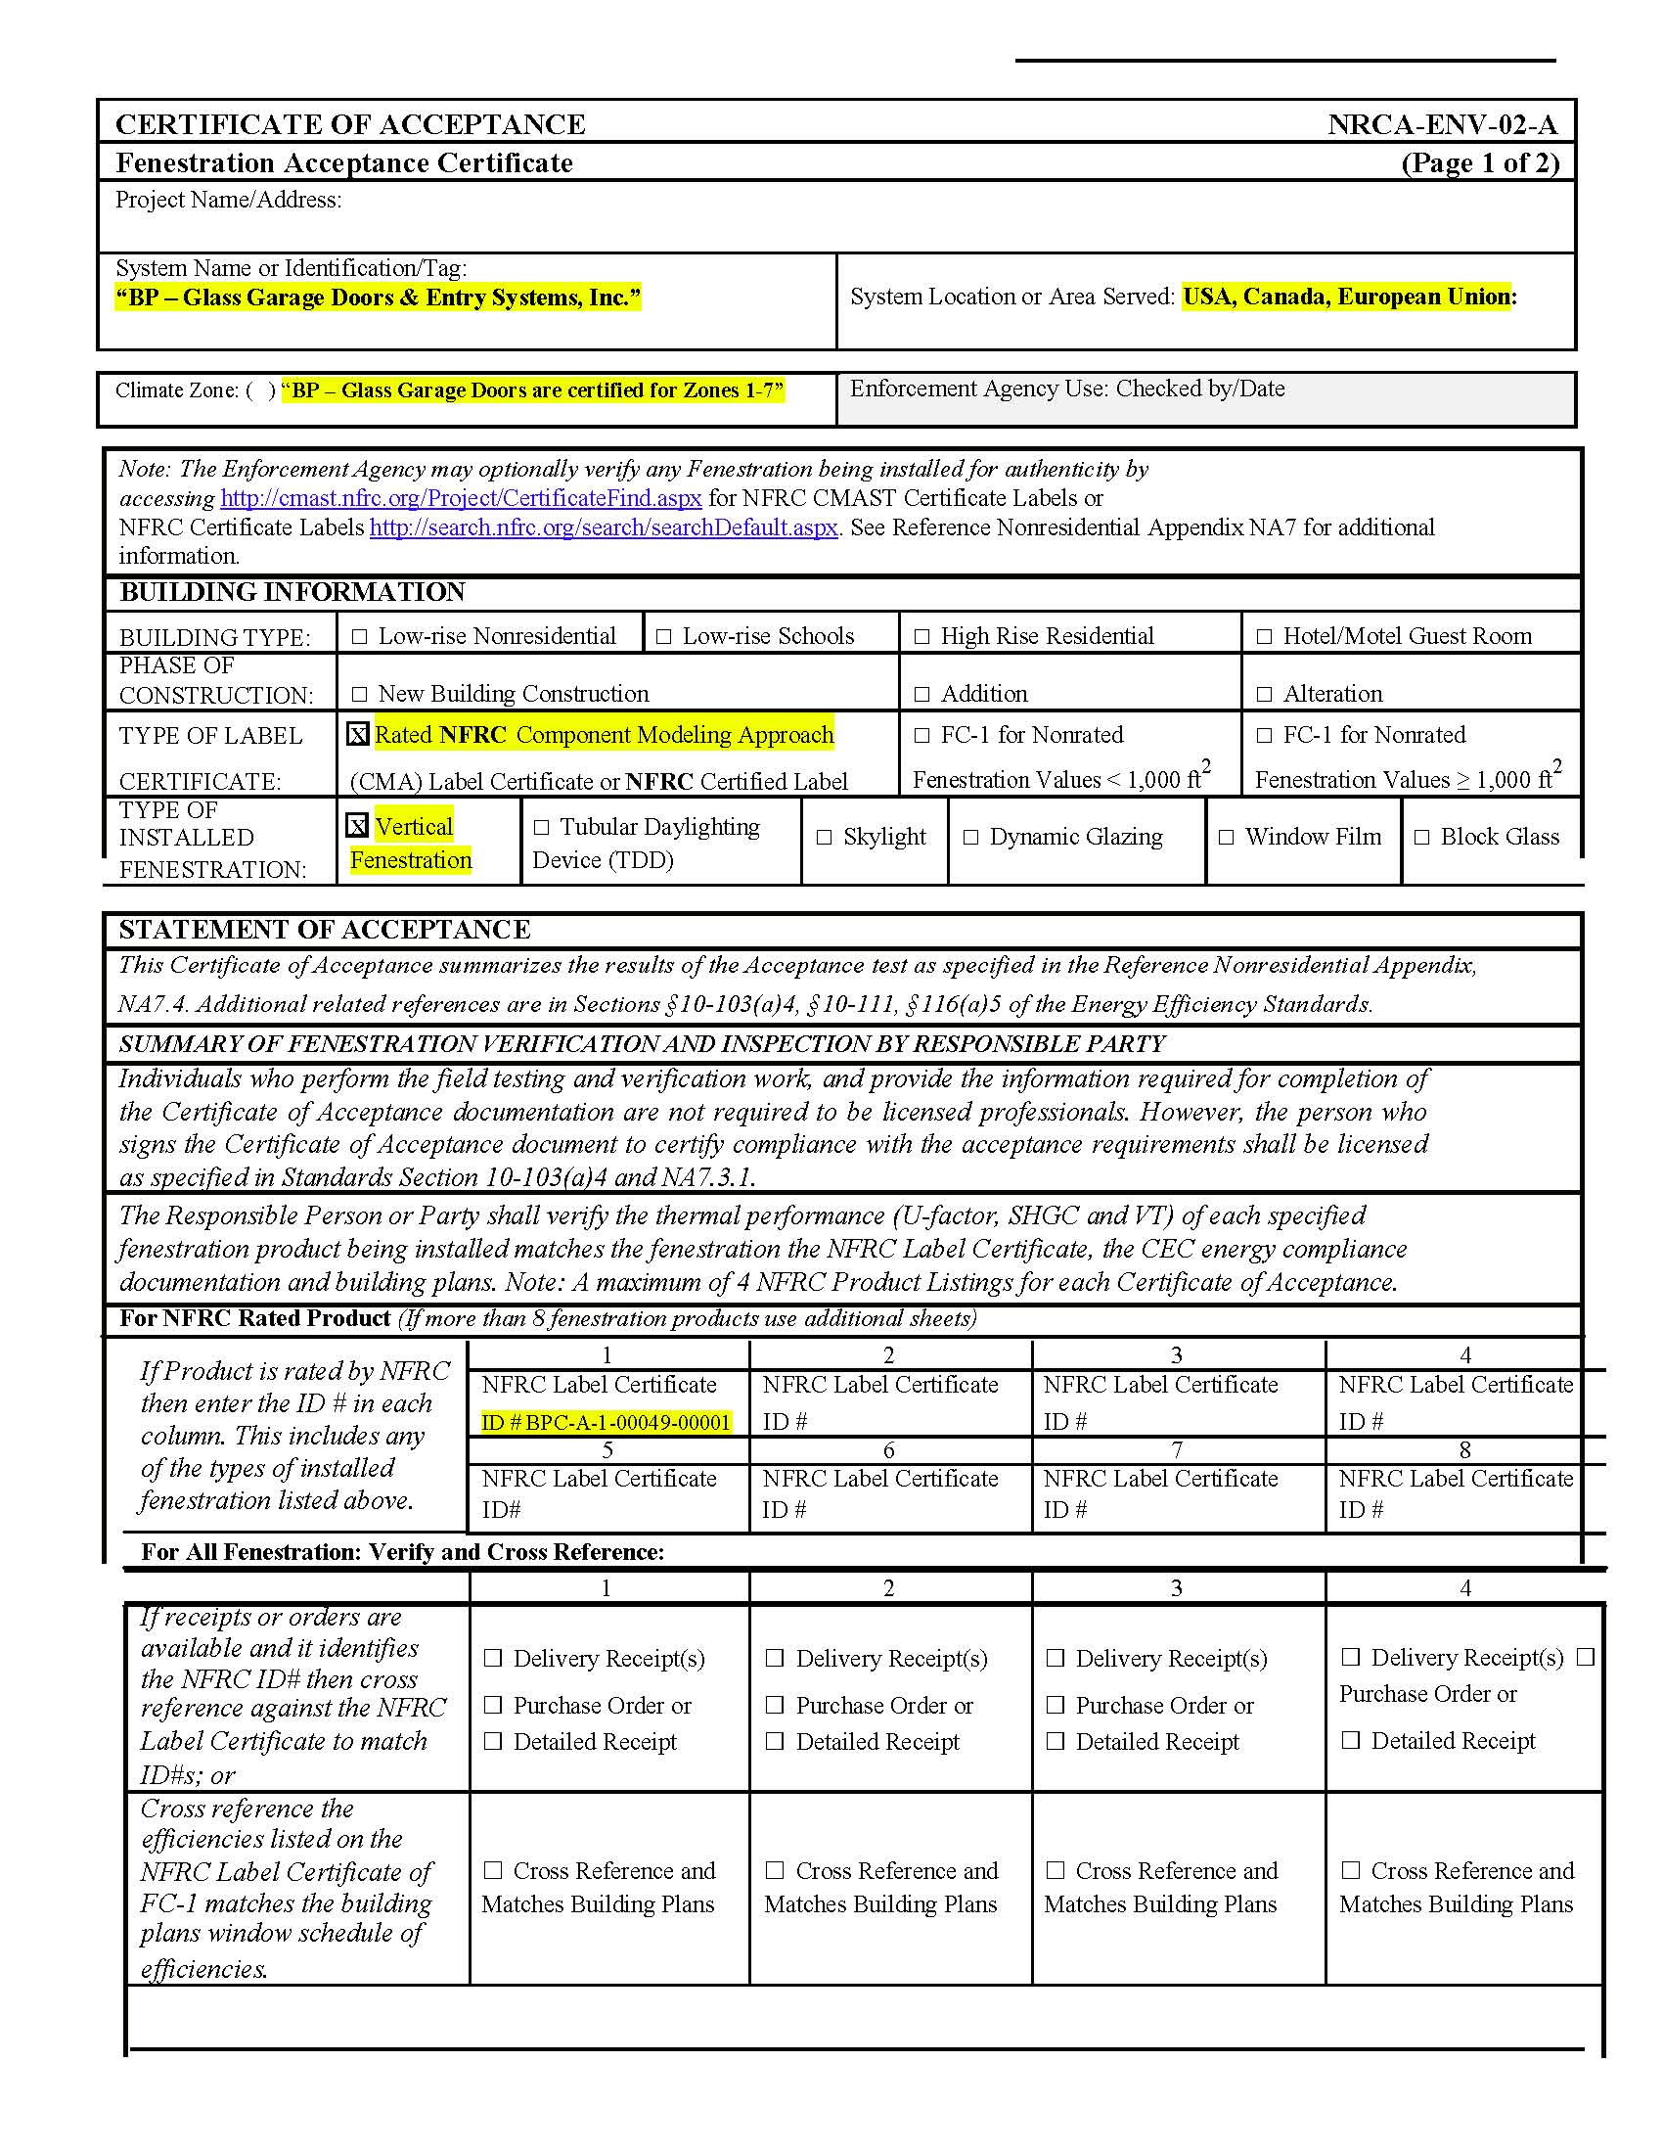
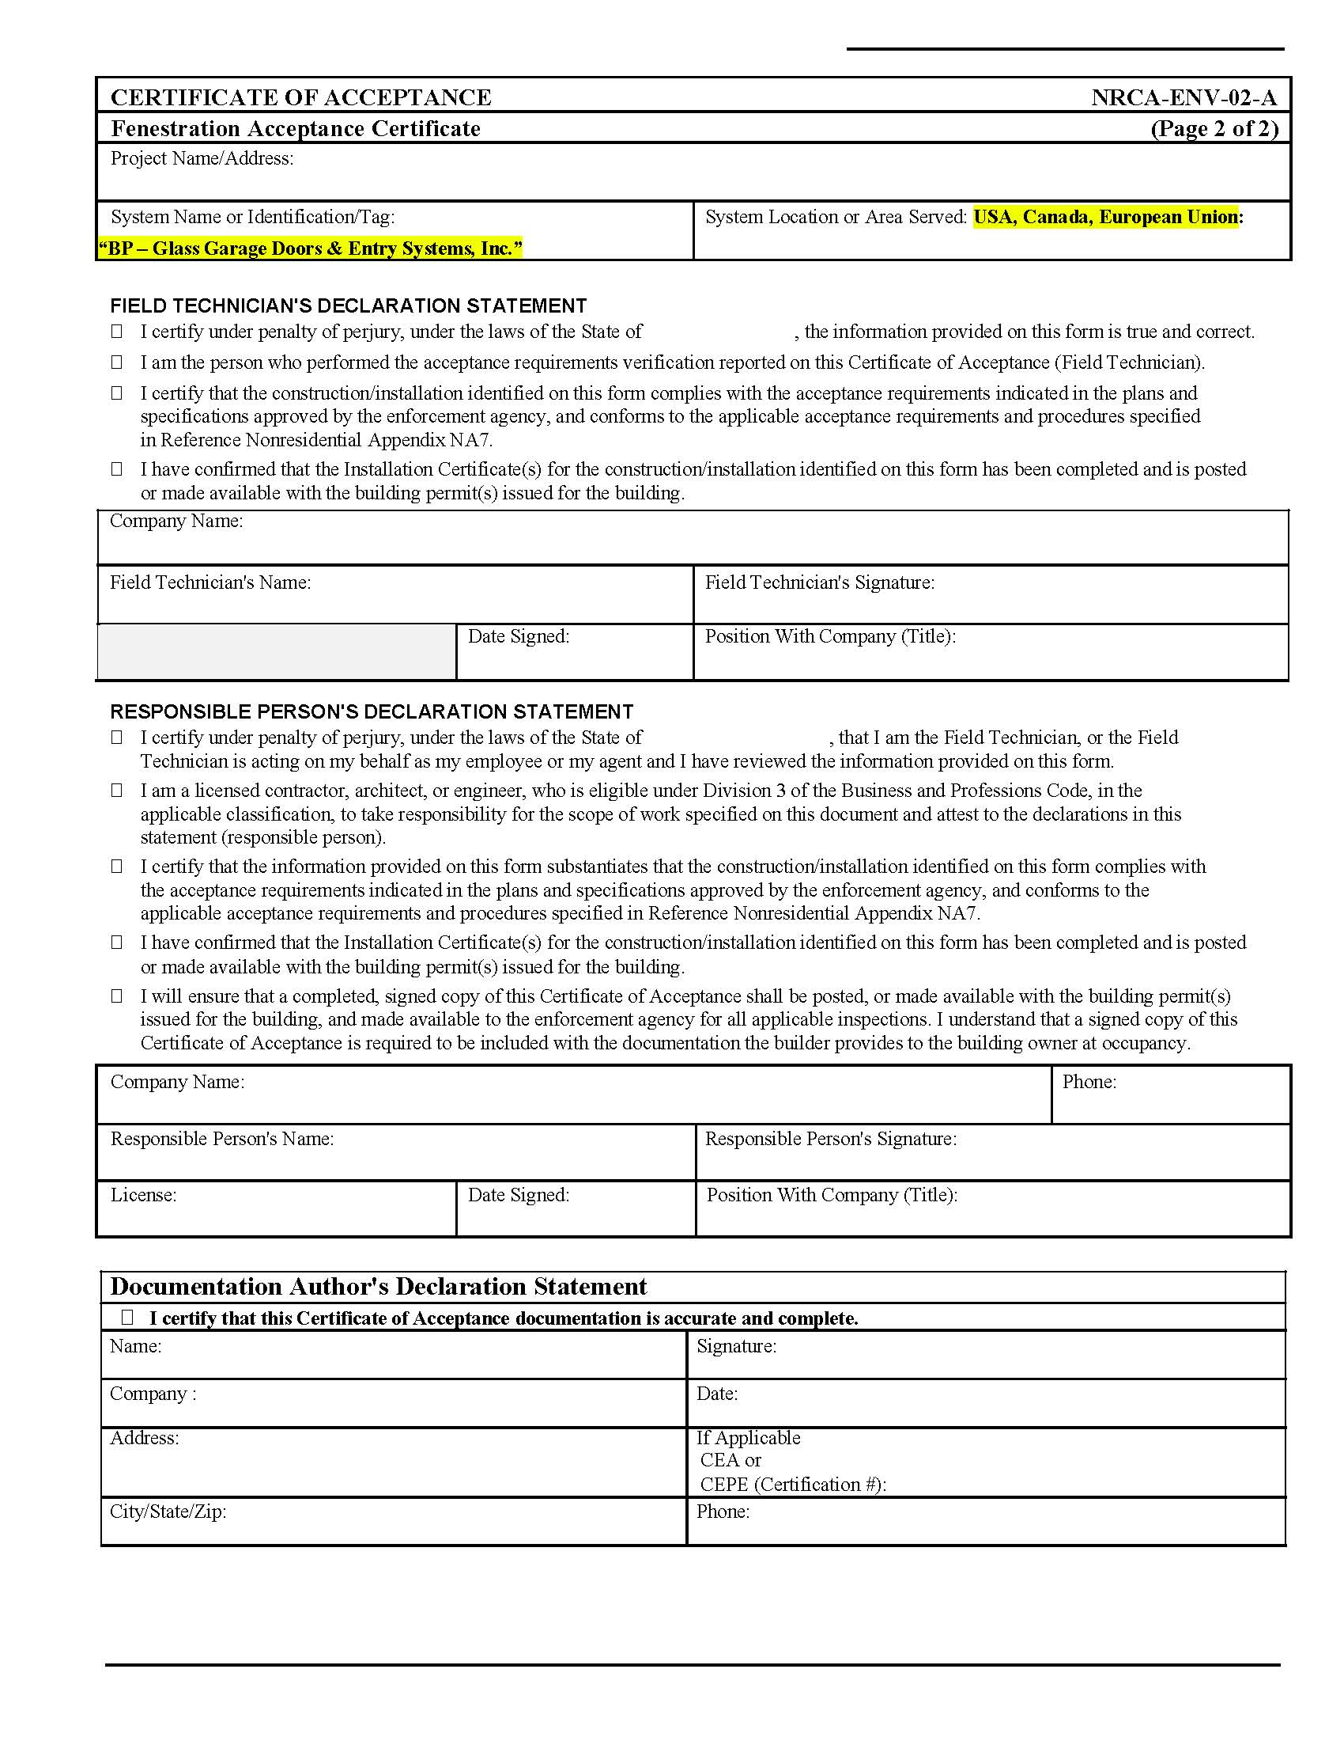

[END OF SECTION 08 36 13.20]

